Aufbau
Hier die Informationen die zur Bestellung der Bauteile und die Bestückung der Platine notwendig sind...

Schaltplan
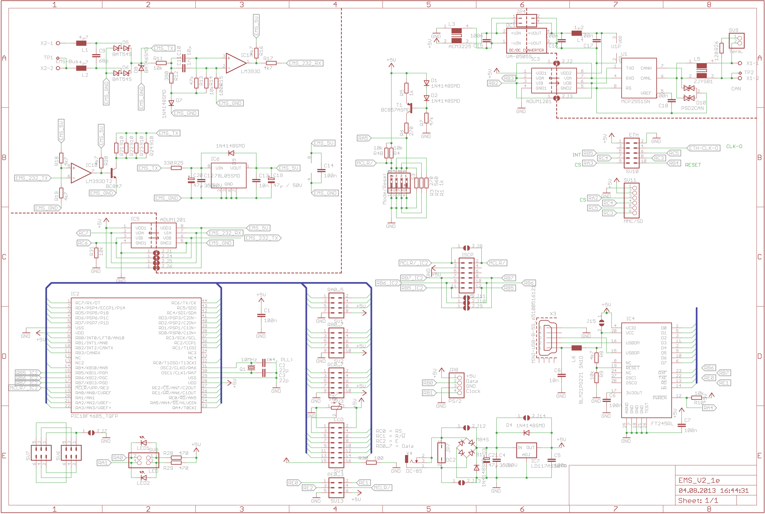

Bauteilliste

ohne CAN
Wert | Bauform | Bauteile
blau | c2 | LED1
orange | c2 | LED2
1n | C-EUC0805 | C11
10µ | C-EUC0805 | C10
10k | R-TRIMM3314J | R27
16MHz | CRYSTALSM49 | Q1
68p | C-EUC0805 | C9
78L05SMD | 78L05SMD | IC6
LD1117 | LD1117S50TR | IC7
100 | R-EU_R0805 | R30
100k | R-EU_R0805 | R15
330 | R-EU_R0805 | R25
390 | R-EU_R0805 | R12
560 | R-EU_R0805 | R2
ADUM1201 | ADUM1201 | IC3, IC5
BAT46SMD | BAT46SMD | D8
BC847 | BC847 | T2
BC857ASMD | BC857ASMD | T1
BLM21PG221 SN1D | WE-KIHQ_0805 | L6
DC-8S | DC-8S | X4
DCPP3 | DCPP3 | X4b
EMS-Bus | W237-02P | X2
FT245RL | FT245RL | IC4
LM393D | LM393D | IC1
MB4S | MB4S | B1
MINI-USB-B | Würth 65100516121 | X3
Mode/Reset | SWS004 | S3
PIC18F4580_TQFP | PIC18F4580_TQFP | IC2
1k | R-EU_R0805 | R1, R5
4µ7 | WE-CBF_1210 | L1, L2
10n | C-EUC0805 | C8, C13
22p | C-EUC0805 | C2, C3, C22, C23
47k | R-EU_R0805 | R7, R13
270 | R-EU_R0805 | R3, R6
330n | C-EUC0805 | C4, C12
470 | R-EU_R0805 | R28, R29
BAT54S | BAT54S | D5, D6
47µ / 50V | CPOL-EUE | C19, C20, C21
910 | R-EU_R0805 | R21, R22, R23, R24
100n | C-EUC0805 | C1, C5, C6, C7, C14, C15, C16, C17, C18
1N4148SMD | 1N4148SMD | D1, D2, D3, D4, D7, D9
4k7 | R-EU_R0805 | R8, R16, R17, R18, R19, R20
10k | R-EU_R0805 | R4, R4B, R9, R10, R11, R14, R31

Bestückung oben
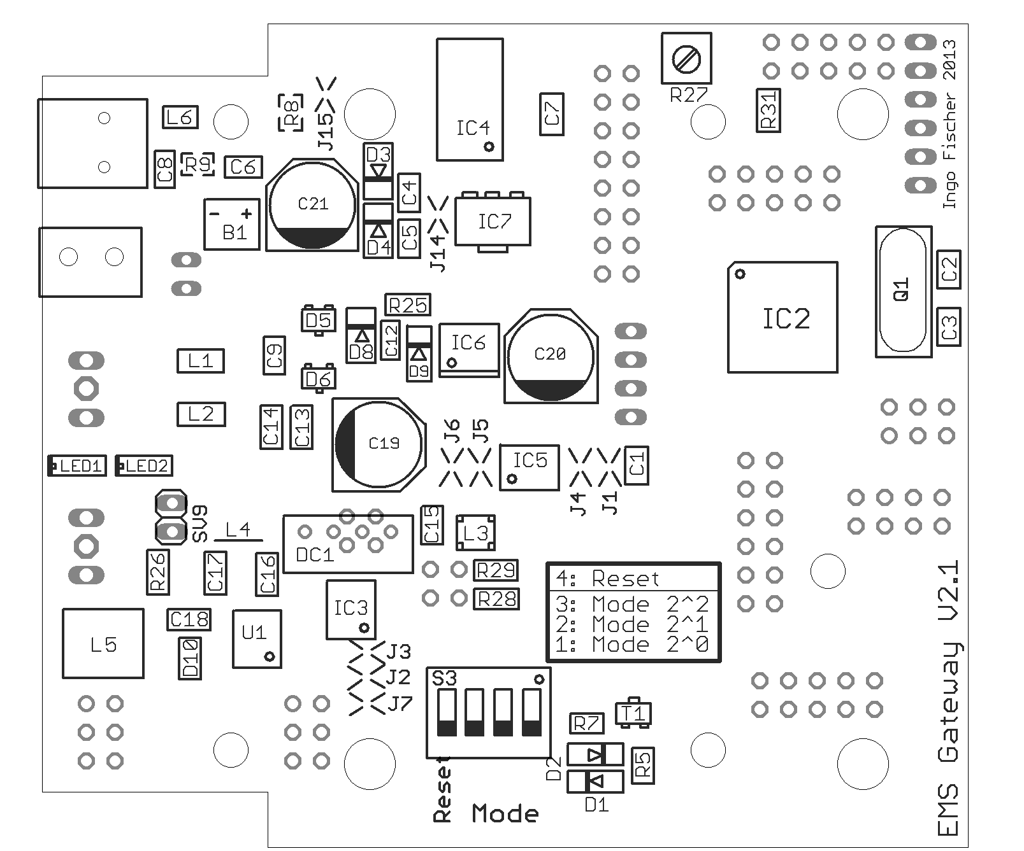

Bestückung unten


